This is our first lecture on Java. Today, we will learn how to write a simple Hello World program in java.

As per my knowledge whenever you are going to learn this java course somewhere you crossed across with two terms i.e. Core Java and Advanced Java. Most of the time students are thinking that java is basically classified into two parts i.e.

1. Core Java and
2. Advanced Java.

But it is true some extent from the point of view of experts who are sharing knowledge because core java is the base to learn advanced java. In other words, we can say with the help of an example. Suppose you want to learn how to ride a bike (with gear), then first of all you have to how to put first gear (with the help of clause, for that you are supposed to release the very slowly otherwise if you will release the gear instantly then definitely you will face with injuries along with your bike) and then only you can use any gear of your choice.

Like the above example on how to ride a bike, you are bound to know the basics of java which is core java and then only you can go for any advance topics in advanced java. So, this differentiation is only on the basis of learning. But Oracle Corporation (Sun microsystem is the initial owner and Oracle acquired Sun microsystem in the year 2010 as shown in the following figure) classified java into three types

* JSE or JAVA SE(Java Standard Edition)
* JEE or JAVA EE(Java Enterprise Edition)
* JME or JAVA ME(Java Micro or Mobile Edition)

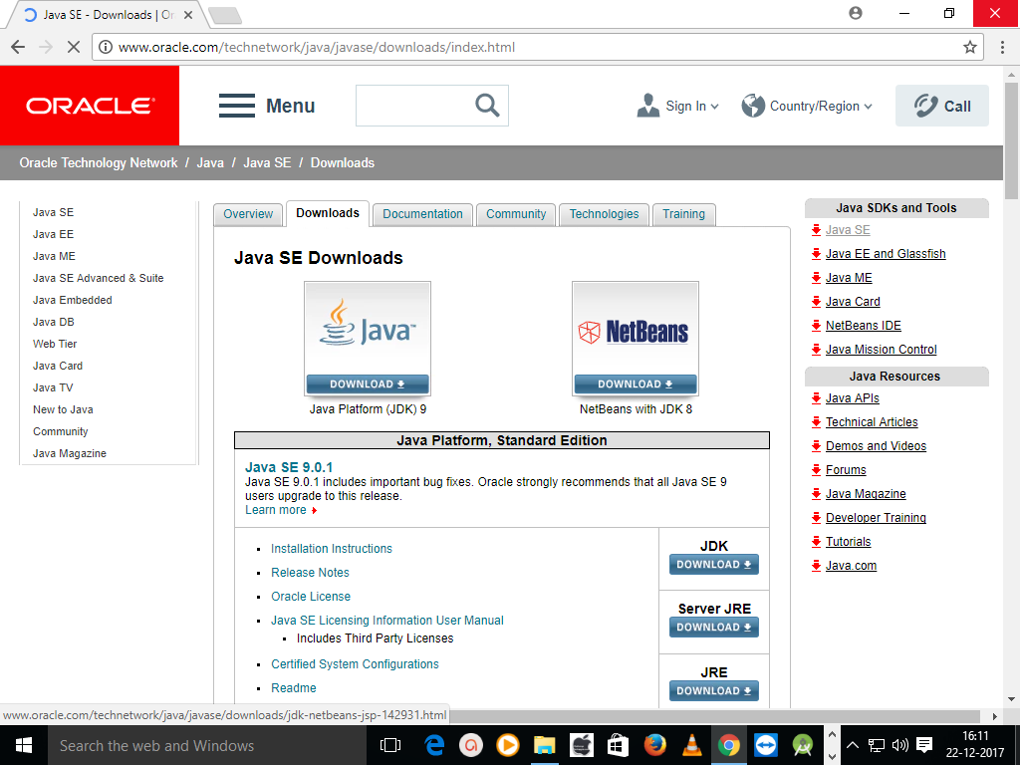

Basically Core Java corresponds to JSE and Advanced Java Corresponds to JEE. Initially JME was applicable for Mobile application and the day from which Android comes into picture of programming it dominates JME. Because of this in java everyone is interested with JSE and JEE for developing different types of application (Small scale, medium scale and large scale application (regarding this we will discuss in later part of our course)) and for mobile application most of the users are interested to go for Android Development (Android development is easier if you have knowledge on core java, better if you know advanced java but it is not compulsory)

But before moving to write the actual program, we must have some basic knowledge like

* Why we need to write the program?
* Where we have to write the program? etc.

So, In order to write a java program we need an operating system may be Windows, Linux, Mac. etc.

Here, we are going to discuss all our programs on the basis of Windows Operating System (Windows 10, you can go for Windows 7 or Windows 8).

Next, in order to write the program, we need an editor like

* Notepad
* Notepad++
* Edit Plus etc.

Besides this we can also go for IDE (Integrated Development Environment) like

* NetBeans
* Eclipse, etc.

Here, we are going to discuss initially with notepad, then after having acquainted with Notepad, we will discuss how to write program using notepad++, Edit Plus, NetBeans, Eclipse etc.

Now, here a question comes into mind that why we are starting with notepad and the one which we mentioned above. So, to get this answer, you must have the knowledge on “How to write program using notepad ?”. This message herewith we have mentioned because we are assuming that you are new to java.

So, if you want to get a brief on java, please follow our advice and then you can make complain that you are the one who is unable to learn java from this site and we will take care to improve ourselves. So, your comments are highly required and we are eagerly waiting for this.

So, upto this we know that to write a simple java program like Hello World, we need an operating system i.e. Windows 10 and an editor i.e. Notepad. But which software we have to execute and run java program and it is JDK (Java Development Kit).

Now, we know that JDK is required to write java program and it is available with different versions and the latest one is JDK 9.

To get JDK, you have to go to Google and there you have to type JDK download.

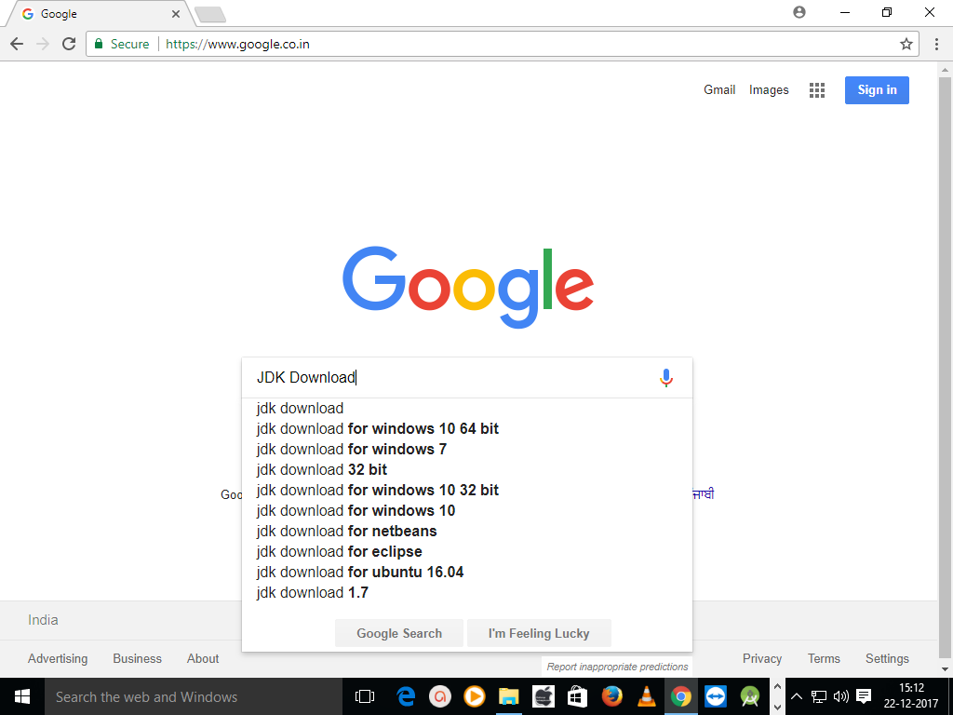

Now, from the above image you can easily know that JDK is available for Windows(10, 7 etc.), Ubuntu(Like ICE-Cream flavaours vanilla, chocolate etc. Ubuntu is one of the flavour of Linux and other flavour of Linux are Mandrake, SuSe , Knoppix etc.). JDK is also for netbeans , eclipse.

But one question must be raised in your mind i.e. what is this 64 bit and 32 bit. Now let me explain what are these ? These are the versions of windows operating system. It means windows operating system are available in two different versions i.e. 32 bit and 64 bit. Now question is how I will know your operating system is of which type. For this follow the following step.

1. In your Search the web and windows bar type This PC.

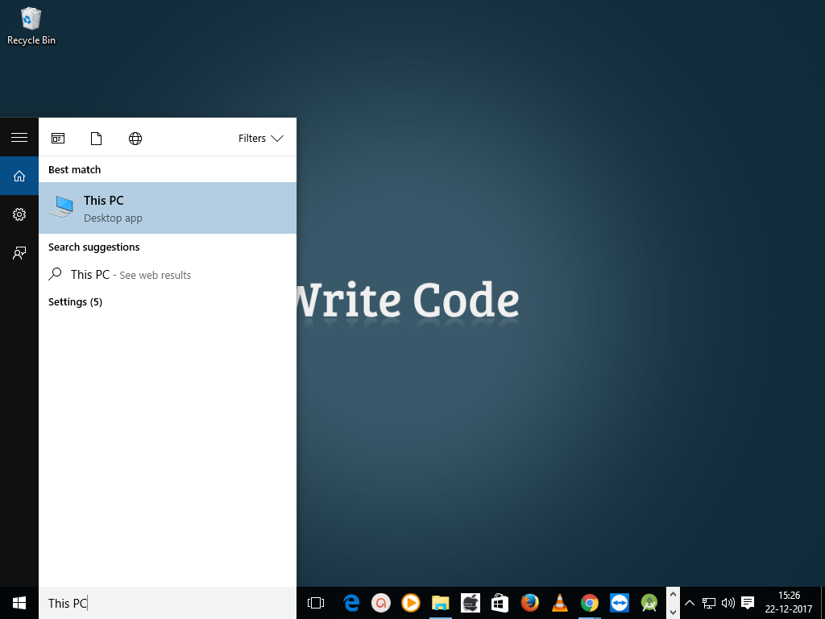

1. Now move your mouse pointer to This PC and right click there which will display pop-menu.

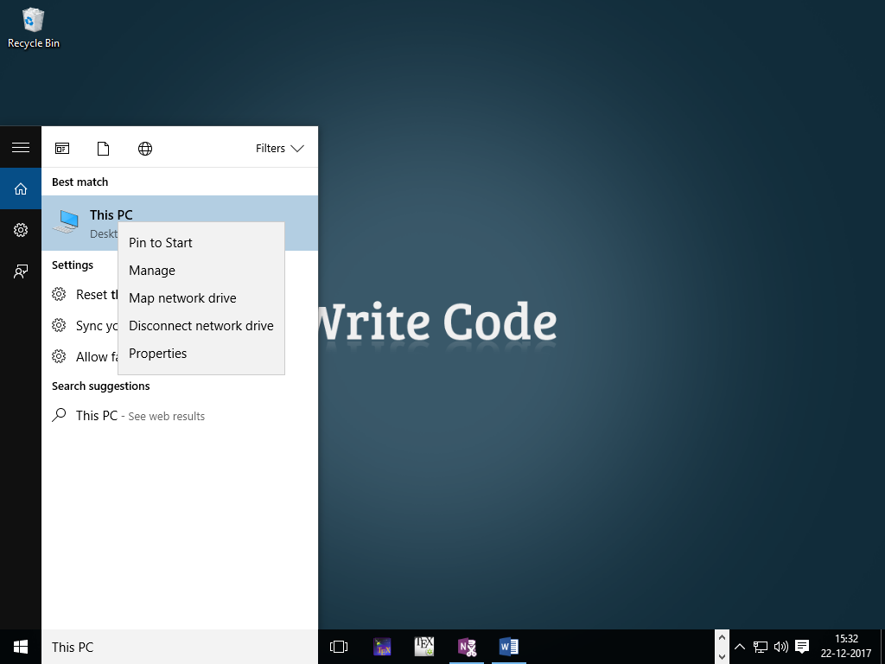

1. Now, click on properties, which will display the following screen.

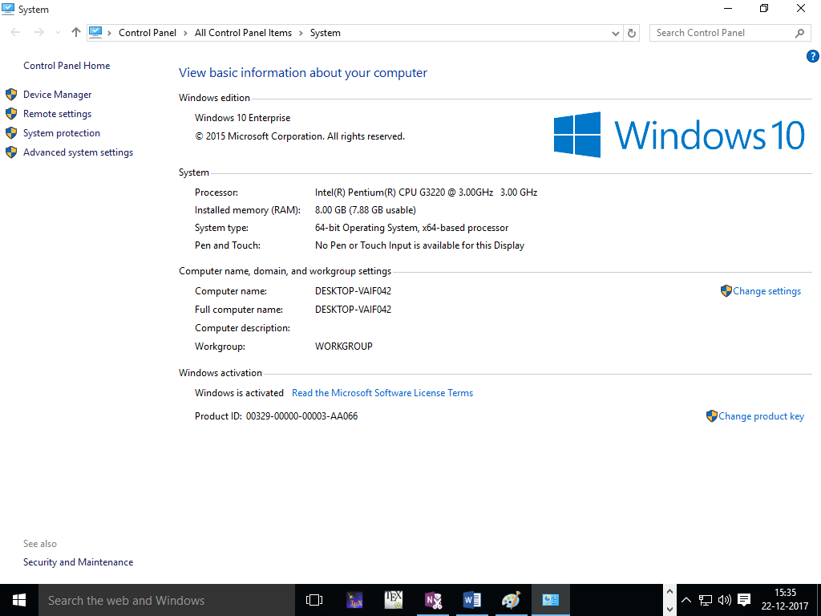

1. Now in the above screen you can see that System Type : 64 bit Operating System (don’t think whatever be written after that) is written and the operating system is also mentioned as Windows 10.
2. And if it is 32 bit Operating System then you will get x64 instead of 64 bit Operating System as shown below.

Figure you have to include.

So, now we know that windows operating system is available in two forms i.e. 64 bit and 32 bit.

Now depending on your operating system type you have to download JDK. So, go to google and type JDK download( as shown in the above figure 1) and press enter. So, you will get the following screen.

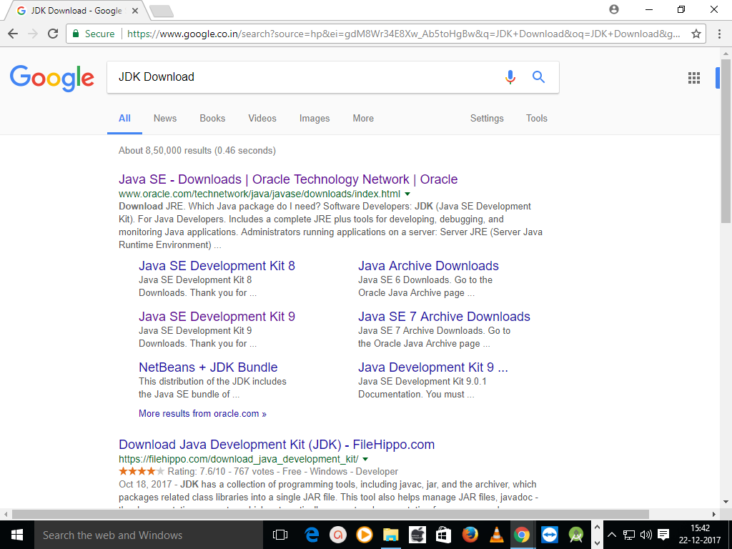

From the above screen you can know that JAVA SE Development Kit 8 and 9 are available (We will use 9 and some situations we will go for JDK 8 and JDK 7 if required for clear understanding on different feature but as a beginner it is not possible right now, so please follow the instructions as mentioned here with). But without choosing any one of the list directly click on Java SE – Download | Oracle Technology Network | Oracle (Now the owner of JAVA is Oracle but earlier it was SUN Microsystem and Oracle acquired Sun Microsystem in the year 2010 as mentioned in the following figure. So, to know the history of JAVA, visit the site as mentioned in the figure)

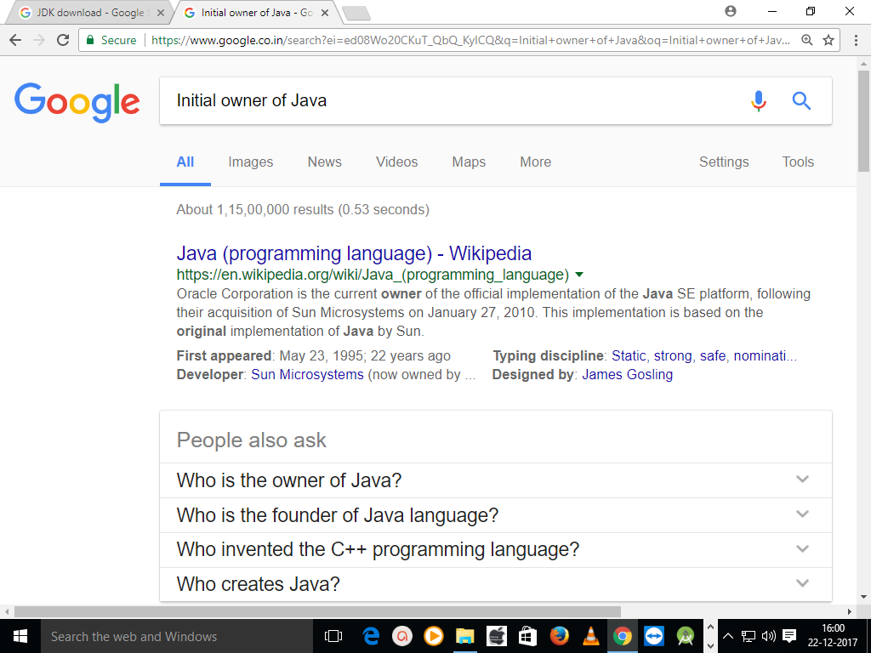

­­So, you can read the history on your free time. Now, let us go to our previous work. So, I think you have already clicked on the site as mentioned earlier i.e. Java SE – Download | Oracle Technology Network | Oracle and you will get the following page as mentioned in the figure.



Now click on Java Platform (JDK) 9 and you will get the following page i.e. JDK available for different Operating System (Remember JDK 9 is available for 64 bit operating system only).

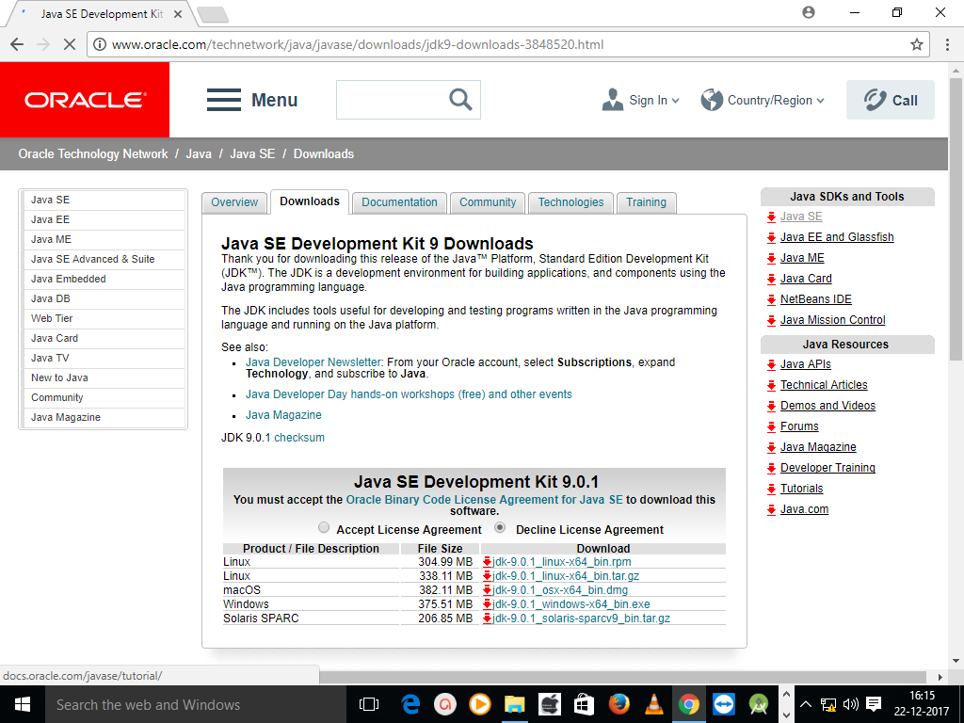

If your operating system is not of 64 bit then download JDK 8 i.e. go to jdk download page and click on JDK SE Development kit 8(already somewhere I have mentioned we will work with JDK 8. So, whether you are going to work with JDK 9 or JDK 1.8 it doesn’t matter but we will first start with JDK 1.8 and then we will go for JDK 8. But my advice is to test the programs in both JDK 8 and JDK 9. And if you will go through the lesson completing one by one you will easily know how to work with more than one JDK version at a time using the same program may be Hello World(have patience for that because no one is going to be a programmer on a single day)), then you will get the following screen.

